Facts About LD 476 An Act To Provide Licensed Assisted Living and Nursing Facilities Levels of Care for Incarcerated Persons

- We should not be locking up nursing home patients. Nor should the Department of Corrections be competing with nursing home facilities in the community.
- There is no death penalty in Maine. Yet there are many who will nonetheless, come to the end of their life while incarcerated.
- Current MDOC policy 27.2 Supervised Community Confinement Procedure I: Supervised Community Confinement for a Terminally Ill or Severely Incapacitated Prisoner allows for the confinement of terminally ill inmates or inmates with a severely incapacitating medical condition in a community setting like a nursing home or long term care facility or a private home. This is an underutilized provision.
- Under this policy the patient remains in the custody of the Maine Department of Corrections and can be returned to prison either at the request of the long term care facility or the Department of Corrections.
- The language in LD 476 would utilize an objective standard used by Medicare and licensed long term care facilities both in Maine and nationally to determine whether a person qualifies for long term care.
- The MDOC facility referred to as the Mountain View Assisted Living Unit, does not meet the community standards for long term care, is not licensed and is in violation of Maine Department of Health and Human Services Division of Licensing and Regulatory Services Regulations Governing the Licensing and Functioning of Assisted Housing Programs:Assisted Living Programs, Part of 10-144 Chapter 11
4.11 Operating without a license

4.11.1 License required. A person, firm, partnership, association, corporation or other entity may not, without first obtaining a license, manage or operate an assisted living program
4.11.2 Civil penalty for operating without a license. A person, firm, partnership, association, corporation or other entity who operates an assisted living program without a license commits a civil violation and is subject to a civil penalty of not less than $500 nor more than $10,000 per day. Each day of violation constitutes a separate offense.

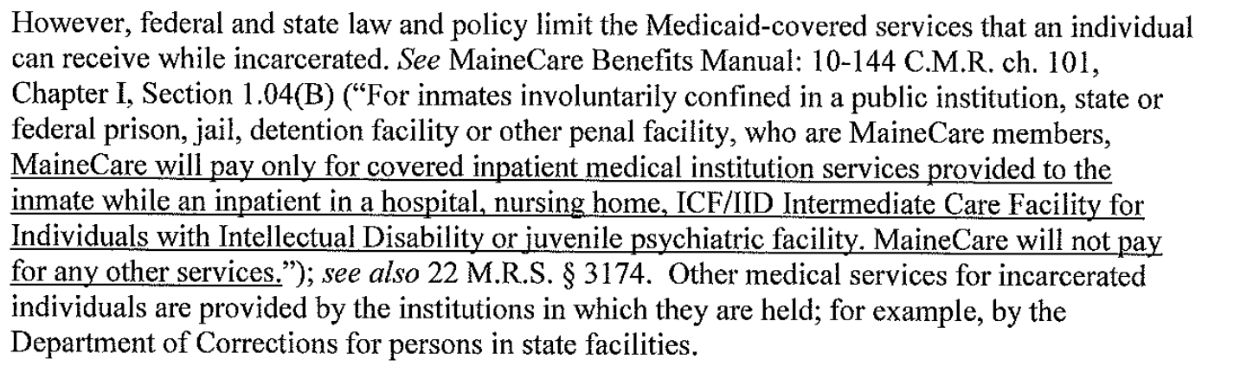
- Nursing home care is covered by MaineCare. Care in a MDOC facility is not covered by MaineCare. See paragraph below
- Fully utilizing MDOC policy 27.2 Procedure I would not only save the department hundreds of thousands of dollars in transport and medical costs, it would also conserve much needed staffing hours. Whenever someone is transported for a medical appointment two corrections officers must accompany the patient.

- By not meeting the community standards of medical care for those who, by objective criteria, should be receiving nursing care the department is opening itself up to legal action.

10. It is the right thing to do. No one should die alone.

